VISHAAAL SV 192412349
ECA0502 EMF

EXP 3
Determination and plotting of Electric field and Electric flux density in sphere full of charges with varying radius.
PROGRAM:
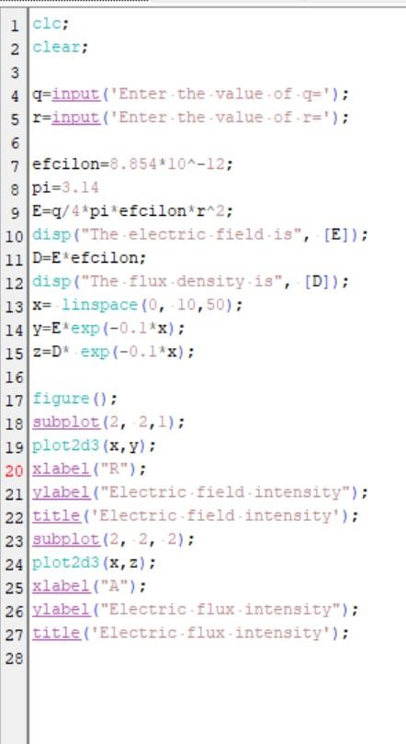

OUTPUT:
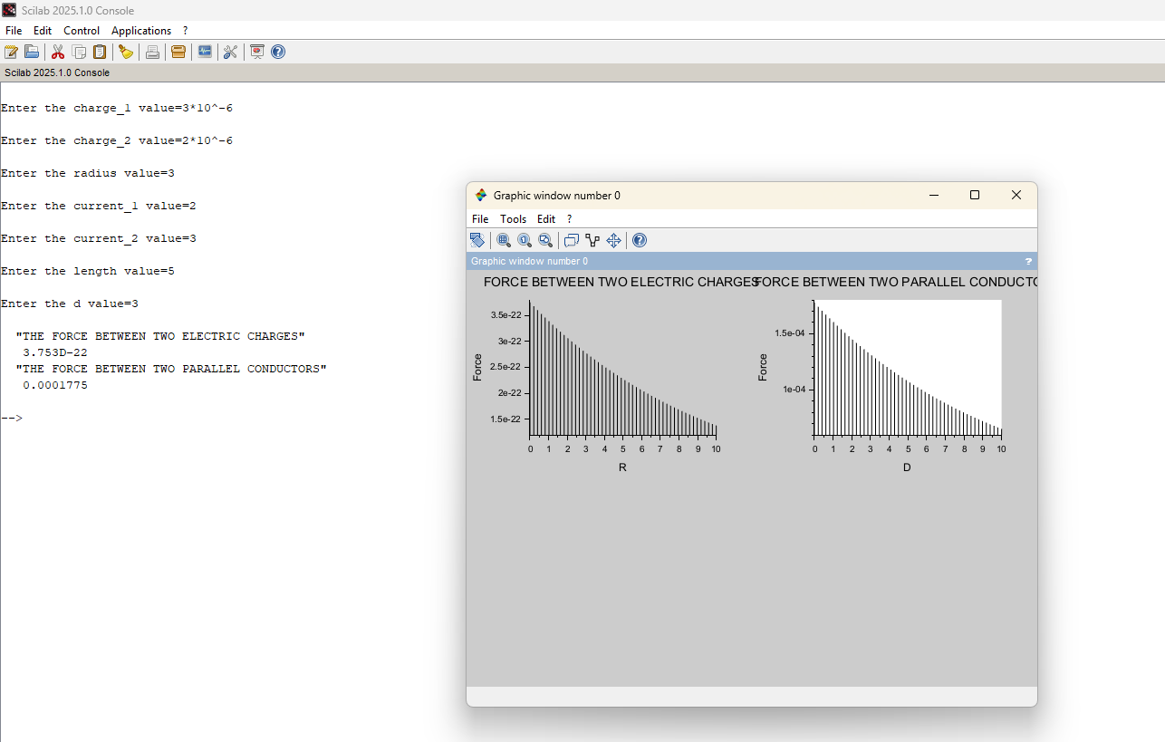
OBSERVATION:
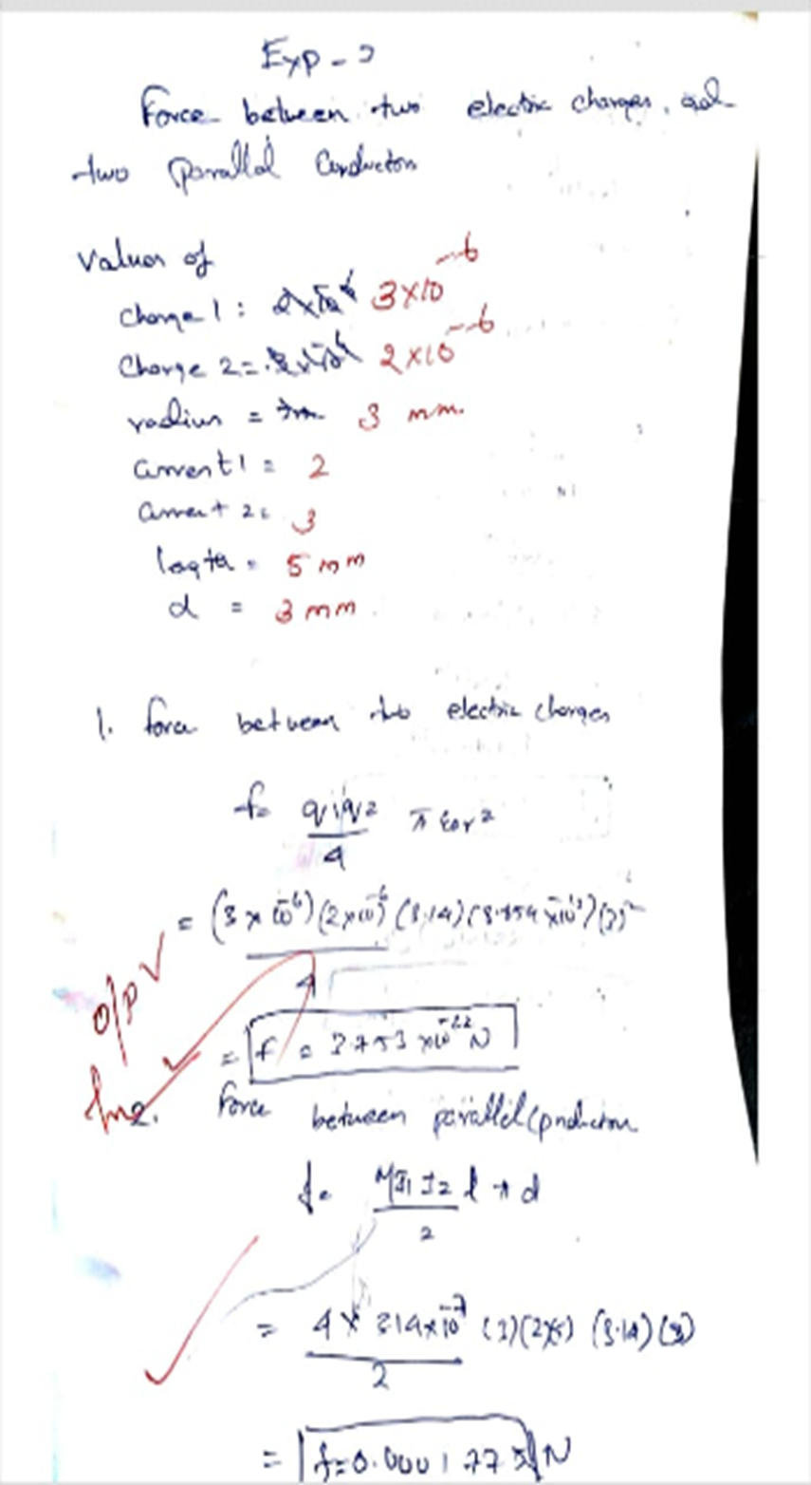

CASE 1:
PROGRAM AND OUTPUT:

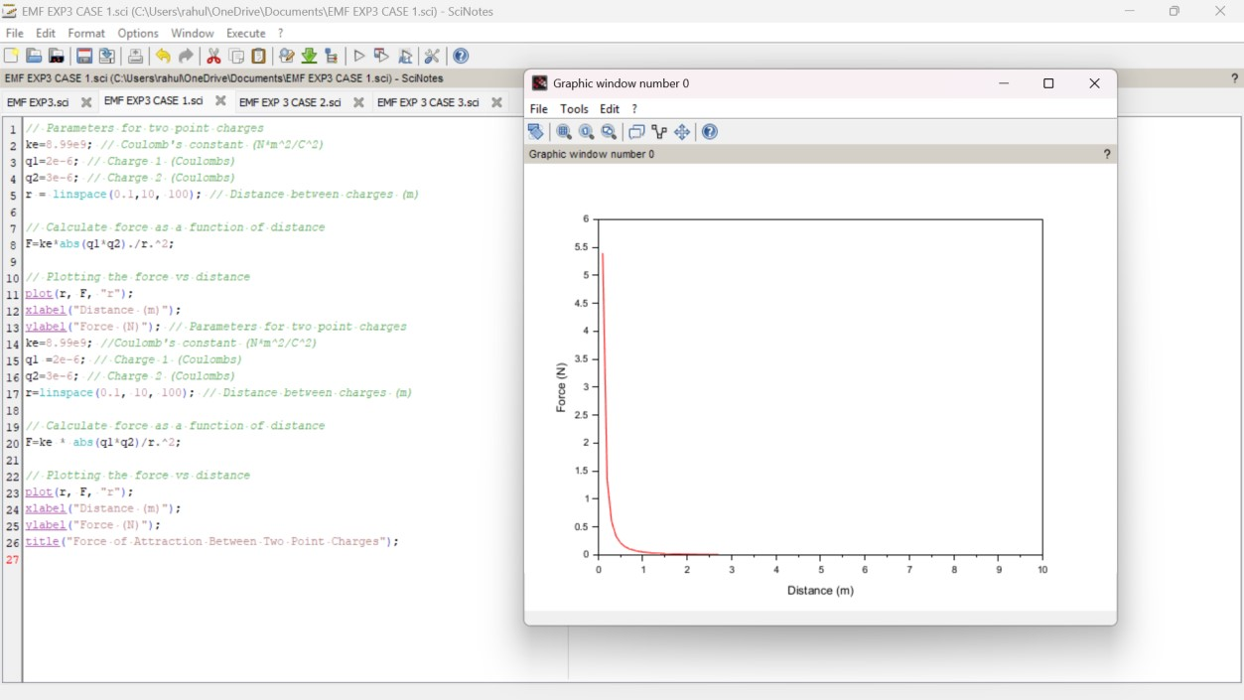
CASE 2:
PROGRAM AND OUTPUT:
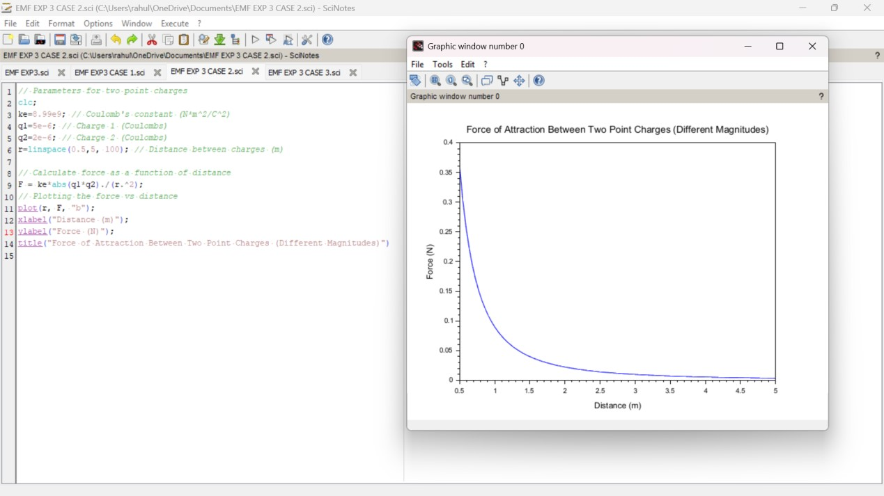

CASE 3:
PROGRAM AND OUTPUT
